**SHRI VAISHNAV VIDYAPEETH VISHWAVIDYALAYA, INDORE**

**SHRI VAISHNAV INSTITUTE OF INFORMATION TECHNOLOGY DEPARTMENT OF COMPUTER SCIENCE & ENGINEERING**



**JANUARY-JUNE 2020**

**Project Report**

***on***

**PACK YOUR BAGS**

***In partial fulfillment of requirements for the degree***

***of***

**BACHELOR OF TECHNOLOGY**

**IN**

**COMPUTER SCIENCE & ENGINEERING**

***Submitted by:***

SHUBHI AGRAWAL [1710DMBCSE01400]

SEJAL CHOURASIA [1710DMBCSE01396]

YASHASVI MAHAJAN [1710DMBCSE01411]

***Under the guidance of***

Mr. ZUBER MIRZA

Mr. RAJESH K CHAKRAWARTI

Mrs. KHUSHBOO KARODIYA

**SHRI VAISHNAV VIDYAPEETH VISHWAVIDYALAYA, INDORE**

**SHRI VAISHNAV INSTITUTE OF INFORMATION TECHNOLOGY**

**DEPARTMENT OF COMPUTER SCIENCE & ENGINEERING**

**DECLARATION**

We here declare that work which is being presented in the project entitled “**PACK YOUR BAGS**” in partial fulfillment of degree of **Bachelor of Technology in Computer Science & Engineering** is an authentic record of our work carried out under the supervision and guidance of **Mr. ZUBER MIRZA/Mr. RAJESH K CHAKRAWARTI/Mrs. KHUSHBOO KARODIYA** Asst. Professor of Computer Science & Engineering. The matter embodied in this projecthas not been submitted for the award of any other degree.

Student1:Shubhi Agrawal signature

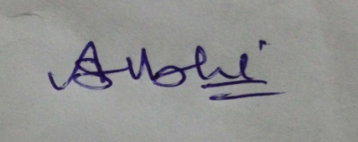

Student2:Sejal Chourasia signature



Student3:Yashasvi Mahajan signature

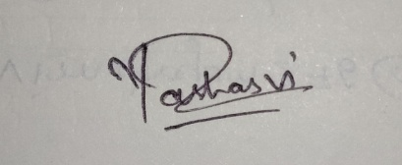

Date: 2-05-2020

**SHRI VAISHNAV VIDYAPEETH VISHWAVIDYALAYA, INDORE**

**SHRI VAISHNAV INSTITUTE OF INFORMATION TECHNOLOGY**

**DEPARTMENT OF COMPUTER SCIENCE & ENGINEERING**

**PROJECT APPROVAL SHEEET**

Following team has done the appropriate work related to the “**PACK YOUR BAGS**” in partial fulfillment for the award of **Bachelor of Technology in Computer Science & Engineering** of “SHRI VAISHNAV INSTITUTE OF INFORMATION TECHNOLOGY” andis being submitted to SHRI VAISHNAV VIDYAPEETH VISHWAVIDYALAYA, INDORE.

**Team:**

1. **Shubhi Agrawal**
2. **Sejal Chourasia**
3. **Yashasvi Mahajan**

**Internal Examiner** **External Examiner**

Mr. ZUBER MIRZA

Mr. RAJESH K CHAKRAWARTI

Mrs. KHUSHBOO KARODIYA

Date: 2-05-2020

**SHRI VAISHNAV VIDYAPEETH VISHWAVIDYALAYA, INDORE**

**SHRI VAISHNAV INSTITUTE OF INFORMATION TECHNOLOGY**

**DEPARTMENT OF COMPUTER SCIENCE & ENGINEERING**

**CERTIFICATE**

This is to certify that **Ms. SHUBHI AGRAWAL**, **Ms. SEJAL CHOURASIA** and **Ms. YASHASVI MAHAJAN** working in a team have satisfactorily completed the project entitled “**PACK YOUR BAGS**” under the guidance of Mr. ABC in the partial fulfillment of the degree of **Bachelor of Technology in Computer Science & Engineering** awarded by SHRI VAISHNAV INSTITUTE OF INFORMATION TECHNOLOGY affiliated to SHRI VAISHNAV VIDYAPEETH VISHWAVIDYALAYA, INDORE during the academic year **January** **2020- June 2020**.

|  |
| --- |
| **Project Guide Project Coordinator**  Mr. ZUBER MIRZA Prof.Chetan Chouhan  Mr. RAJESH K CHAKRAWARTI  Mrs. KHUSHBOO KARODIYA |
|  |

Dr. Anand Rajavat

**Director & Head,**

**Department of Computer Science & Engineering**

**ACKNOWLEDGEMENT**

We are grateful to a number of persons for their advice and support during the time of complete our project work. First and foremost our thanks goes to **Dr. Anand Rajavat** Head of the Department of Computer Science & Engineeringand **Mr. Zuber Mirza/Mr. Rajesh K Chakrawarti/Mrs. Khushboo Karodia** the mentor of our project for providing us valuable support and necessary help whenever required and also helping us explore new technologies by the help of their technical expertise. His direction, supervision and constructive criticism were indeed the source of inspiration for us.

We would also like to express our sincere gratitude towards our Director **Dr. Anand Rajavat**  for providing us valuable support.

We are really indebted to **Prof. Chetan Chauhan,** project coordinator for helping us in each aspect of our academics activities. We also owe our sincere thanks to all the **faculty members** of Computer Science & EngineeringDepartment who have always been helpful.

We forward our sincere thanks to all **teaching and non-teaching staff** of Computer Science & Engineering department, SVVV Indore for providing necessary information and there kind co-operation.

We would like to thanks our parents and family members, our classmates and our friends for their motivation and there valuable suggestion during the project. Last, but not the least, we thank all those people, who have helped us directly or indirectly in accomplishing this work. It has been a privilege to study at SHRI VAISHNAV VIDYAPEETH VISHWAVIDYALAYA, INDORE.

**ABSTRACT**

The recent past showed a greater interest in recommender techniques. Now-a-days there are many travel packages existing from different websites to almost all the places over the world. A customer finds it very difficult to search for the best package as he/she has to browse multiple websites, contact many travel agents and etc. which is a tedious process and is time consuming. There should be a system where the user should find the best package on the Internet with a single click.

To address this issue, we adopt Travel Planning System which offers the best package among all the other packages that are on the web. This project will help tourist to suggest the best Destinations according to different seasons and themes.It also prevent users from suffering as it tells the weather condition of the selected destination through Weather Forecasting. We are providing many options for each destination such as meals, sightseeing where user can see the famous food places and adventurous tourist places of a particular destination based on his location as we are using google map. You can also book hotels to stay and flight, train, rental cars to travel according to your budget.

You can also view reviews of other visitors so that you may get to know about their experience of our website.

**LIST OF FIGURES Page No.**

1. Admin level 1 DFD 25
2. User level 1 DFD 26
3. User level 2 DFD 26
4. Transportation 27
5. Hotel 27
6. Packages 28
7. Conceptual level class diagram 29
8. Conceptual level activity diagram 30
9. Data flow diagram 31
10. E-R diagram admin 32
11. E-R diagram user 33
12. E-R diagram Hotel booking 34
13. Detailed class diagram 35
14. Sequence diagram for admin 36
15. Sequence diagram for customer 37
16. Collaboration diagram 38
17. State diagram 38
18. Activity diagram 39
19. Component & deployment diagram 40

**LIST OF SNAPSHOTS Page No.**

1. Home page 43
2. Sign-up page 44
3. Login page 44
4. Explore destinations by season 45
5. Popular destinations 45
6. Hotel booking 46
7. Flight booking 46
8. Train booking 47
9. Rental cars booking 47

10.Meals 48

11. Sightseeing 48

12. Dashboard 49

13. Django Administration 50

**TABLE OF CONTENTS Page No.**

Declaration 2

Project Approval Sheet 3

Certificate 4

Acknowledgment 5

Abstract 6

List of Figures 7

List of snapshots 8

CHAPTER 1 – **INTRODUCTION 11-15**

1. Introduction 11
2. Problem Statement 11
3. Need for the proper System 12
4. Objective 12
5. Modules of the system 12-15
6. Scope 15

CHAPTER 2 - **LITERATURE SURVEY 16-17**

1. Existing System 16
2. Proposed System 16
3. Feasibility Study 16-17
   1. Technical Feasibility 16
   2. Economical Feasibility 16-17
   3. Operational Feasibility 17

CHAPTER 3 – **REQUIREMENTS ANALYSIS 18-21**

1. Method used for Requirement analysis 18
2. Data Requirements 18
3. Functional Requirements 18-20
4. Non Functional Requirements 20
5. System Specification 21
   1. Hardware specification 21
   2. Software specification 21

CHAPTER 4 –**DESIGN 22-34**

4.1Software Requirements Specification 22-28

* 1. Glossary 22
  2. Supplementary Specifications 22-24
  3. Use Case Model 25-28
  4. Conceptual level class diagram 29
  5. Conceptual level activity diagram 30
  6. Data flow Diagram( Level 0,1,2) 31
  7. Database Design (ER-Diagram) 32-34

CHAPTER 5 – **SYSTEM MODELING 35-41**

5.1 Detailed Class Diagram 35

5.2 Interaction Diagram 36-37

5.2.1 Sequence Diagram 36-37

5.2.2 Collaboration Diagram 38

5.3State Diagram 38

5.4Activity Diagram 39

5.5Component Diagram & Deployment Diagram 40

5.6Testing 40-41

.

CHAPTER 6 – **CONCLUSION & FUTURE WORK 42**

6.1Limitation of Project 42

6.2Future Enhancement 42

CHAPTER 7 - **BIBLIOGRAPHY & REFERENCES 43-50**

* 1. Other Documentations & Resources 43

7.2 Snapshot (with description) 43-50

**CHAPTER-1 INTRODUCTION**

* 1. **Introduction**

# TRAVELLING AND EXPLORING NEW PLACES IS PASSION FOR MANY

 Travelling soothes mind and give you chance to know yourself closely.It reenergise the lost soul. In daily hectic life everyone is busy with their responsibilities, travelling somehow relaxes your mind.

It gives you chance to enjoy natural beauty and discover something new. It gives your dreams feathers of imagination, you can imagine beyond the world. While travelling people learn to grow out of their limited thinking area. Moreover It develops sense of unity and more love among family. When people go outside their comfort zone they allow their mind to relax and enjoy sunset, landscapes and natural beauty.

“Pack your bags” is a project to create a travelling website. It provides a convenient way for a customer to travel across the India. It automates the processes and activities of a travel planning and make an easier task of searching places and for booking train, flight or bus and manage your time.

* 1. **Problem Statement**

In Present travelling websites,

* Only the purpose of exploring is fulfilled, suggestions are not provided for some other purposes for e.g, if you wants to go for business deals,medication,etc.
* Destinations are not suggested according to the seasons.
* In general the traveller is not aware of the weather conditions of the place where he wants to explore, and so he has to face the natural calamities.
* After planning and booking ,if he gets to know about the weather Conditions of the place then he has to dismiss his plan and has to bear the Consequences(such as wastage of money, time, excitement ).

In “Pack your bags”,

* All your purposes are fulfilled.
* Destinations are suggested according to the seasons.
* Weather forecasting is used, and prevents customers from suffering.

The project should be very easy to use enabling even a novice person to use it.

**1.3 Need for the proper system**

* Travel Websites help a great deal in planning your trip. In our of travel site you can book your trains, hotels, vacation packages, customize your vacation and even get honest traveler reviews about the place. There are other kinds of travel websites run by individual travelers where they share their personal travel stories, itineraries, destination guides, travel tips, and tricks to help you avoid the mistakes and travel more and far.
* The purpose of travel sites is, that you can easily get all the information related to travel and easily asked travel-related queries. In our travel sites, the information related to tours and destinations is mentioned.

**1.4 Objective**

The ‘Pack your Bags’ is a web based application. The main purpose of ‘Pack your Bags’ is to provide a convenient way for a customer to travel across the India. And we also provides suggestion to explore the places according to different seasons. The objective of this project is to develop a system that automates the processes and activities of a travel planning. In this project, We will make an easier task of searching places and for booking train, flight or bus and manage your time. . In the present system a customer has to approach various agencies to find details of places and to book tickets. This often requires a lot of time and effort. We provide approach skills to critically examine how a tourist visits and its ability to operate in an appropriate way when dealing with the consequences of tourism, locally, regionally, and nationally including visitor security and ecological influences. It is tedious for a customer to plan a particular journey and have it executed properly. The project ‘Pack your Bags’ is developed to replace the currently existing system, which helps in keeping records of the customer details of destination as well as payment received.

**1.5 Modules of the system**

**User Management**   
  
a. Login.  
  
b. User profile.   
  
c. Update information.   
  
d. Role based rights.

**Administrator module**

This module provides administrator related functionality like from this module use can add route information, bus information, train information, flight information, tour packages, travel packages, bus seat details, etc. From this module Admin can view daily, weekly and monthly report. This module is develop for admin of the website and admin can add, delete, edit and view the data related to places, travels, routes, bookings from this module.   
  
a. Manage user information.   
  
b. Update information.   
  
c. Manage Trips.   
  
d. Manage Transportation.   
  
e. Manage hotel, Bookings.

**Hotel Module**   
Details of the hotels in which the accommodation of the customer will be done during the tours. Details like availability of meals, station-pickup and drop facility and  
contact no. of the hotels are also provided to the customers on special request.   
  
a. Registration (as user)   
  
b. Registration (as Hotel)   
  
c. Search

**Transportation Module**

a. Flight   
  
b. Train   
  
c. Bus   
  
**Testimonials module**   
  
This is testimonials module where passenger can post feedback after the journey and they can share their experience. Users of this application can post their opinions, complaints and suggestions regarding

**Payment Module**   
  
a. pay payment through PayPal   
  
b. pay payment through Draft  
  
**Search Module**   
  
a. search City wise hotels, flights, packages, bus, rails and events.

**Routes module**  
This will display the route information of Source location and destination location. Use can also check bust routes for his destination. User can check bust rout train tout and car rout for his journey and can select any rout packages from the available tour packages. From this module use can also get information related to various routes connecting sources and destinations. For each route, information such as source, destination, fare, reservation details, pick up points etc are provides.

**Reservations module**  
This module is for passengers where passenger can reserve the seats by making payment. Using this module user can book bus ticket or train ticket. From this module user can also book tickets or cancel previously booked tickets. The module maintains the details of all reservations made so far and allows administrator to either confirm or reject the bookings.   
this portal and services to the administrator. Accordingly, the administrator can take various steps to act on the complaints and suggestions.   
  
**Tour Details**   
Details of different types of tours which includes tours like family tours, couple tours, general tours, date and time of departure and the fair of the tours etc are maintained. As the customer ask for the details of a particular tour, the tours and travel management system gives the details of the related place where tourist wants to go and the date and time of the tour, no. of seats available of that particular tour, fair of the tour, details of discount on a particular tour package if any. Details of the pick-up facilities and the drop facilities are also maintained if any.

**Non- Functional Requirements**

This requirement specification must have the system properties. Conceptually every SRS should have the components:

Functionality

Performance

Design constraints imposed on an implementation

External interfaces

**1.6 Scope**

This application is develop to provide best travelling services to the customers and travel agents. We have developed tours and travel management system to provide a search platform where a tourist can find their tour places according to their choices. This system also helps to promote responsible and interesting tourism so that people can enjoy their holidays at their favorable places according to season.This system also helps to develop tourism with different cultures so that they enrich the tourism experience and build pride. We develop this system to create and promote forms of tourism that provide healthy interaction opportunities for tourists and locals and increase better understanding of different cultures, customs, lifestyles, traditional knowledge and believes. This system also provide a better way to connect with various events.   
  
This system also gives tours related information like which places are tourist attractions, cities, and provinces. Tourist can also get the Map and navigation system and temperature and weather information. Tourist can also book tours through our “Pack your Bags”. This system also keeps a history of visited places of its users.

CHAPTER-2 LITERATURE SURVEY

**2.1 Existing System**

In the existing travelling websites,

* Only the purpose of exploring is fulfilled, suggestions are not provided for some other purposes for e.g, if you wants to go for business deals,medication,etc.
* Destinations are not suggested according to the seasons.
* In general the traveller is not aware of the weather conditions of the place where he wants to explore, and so he has to face the natural calamities.
* After planning and booking ,if he gets to know about the weather Conditions of the place then he has to dismiss his plan and has to bear the Consequences(such as wastage of money, time, excitement ).
* Travellers themselves needs to search for the nearby places on the internet to explore.

**2.2 Proposed System**

In the proposed travelling website”Pack your Bags”,

* All your purposes are fulfilled.
* Destinations are suggested according to the seasons.
* Weather forecasting is used, and prevents customers from suffering.
* We are giving the pop ups to suggest the nearby exploring places.

The project should be very easy to use enabling even a novice person to use it.

**2.3 Feasibility Study**

**Feasibility Report:**

Preliminary investigation examines project feasibility, the likelihood the system will be useful to the organization. The main objective of the feasibility study is to test the Technical, Operational and Economical feasibility for adding new modules and debugging old running system. All systems are feasible if they are given unlimited resources and infinite time. There are aspects in the feasibility study portion of the preliminary investigation: • Technical Feasibility • Operation Feasibility • Economical Feasibility

**2.3.1 Technical Feasibility**

The technical issue usually raised during the feasibility stage of the investigation includes the following: • Does the necessary technology exist to do what is suggested? • Do the proposed equipments have the technical capacity to hold the data required to use the new system? • Will the proposed system provide adequate response to inquiries, regardless of the number or location of users? • Can the system be upgraded if developed? • Are there technical guarantees of accuracy, reliability, ease of access and data security?

**2.3.2 Economic Feasibility**

A system can be developed technically and that will be used if installed must still be a good investment for the organization. In the economical feasibility, the development cost in creating the system is evaluated against the ultimate benefit derived from the new systems. Financial benefits must equal or exceed the costs. The system is economically feasible. It does not require any additional hardware or software.

**2.3.3 Operational Feasibility**

Proposed projects are beneficial only if they can be turned out into information systems, which will meet the organization’s operating requirements. Operational feasibility aspects of the project are to be taken as an important part of the project implementation. Some of the important issues raised are to test the operational feasibility of a project includes the following: - • Is there sufficient support for the management from the users? • Will the system be used and work properly if it is being developed and implemented? • Will there be any resistance from the user that will undermine the possible application benefits? This system is targeted to be in accordance with the above-mentioned issues. Beforehand, the management issues and user requirements have been taken into consideration. So there is no question of resistance from the users that can undermine the possible application benefits. The well-planned design would ensure the optimal utilization of the computer resources and would help in the improvement of performance status.

**CHAPTER- 3 REQUIREMENTS ANALYSIS**

**3.1 Method used for Requirement analysis**

* Data Flow Diagram: a means of representing a system at any level of detail with a graphic network of symbols showing data flows, data stores, data processes, and data sources/destination.
* Data Table: the connection between the output of one object or process and The Input to another.
* Function: it describes in the statement of scope are evaluated and in some cases,it is refined to provide more detail prior to the beginning of estimation.
* Performance: Performance is measured by processing speed, response time, resource consumption, throughput and efficiency.
* Requirement analysis: requirement analysis categorizes requirement and organizes them into related subsets.
* Requirement specification: it is the final work product produced by the system and requirements engineer.

**3.2Data Requirements**

The customers must register to create the account and login using username and password to use function in the application

-> collect data of customers personal information (name, e-mail address, mobile number)

- The customers can view or find the information of hotel, tourist attraction.

- The customers can search for booking hotel, flight after select date time to go.

- The customers can find the information and the calculate system of time, ways, price to the destination place.

- The customers can see private history with analyse with booking, transport, price, time, etc. And keep or share the information.

- The customers can manage and see their profile.

- The customers can find the location themselves.

- The customers can see whether of each area inside map or place that they want to go.

**3.3Functional Requirements**

**User Management**   
  
a. Login.  
  
b. User profile.   
  
c. Update information.   
  
d. Role based rights.

**Administrator module**

This module provides administrator related functionality like from this module use can add route information, bus information, train information, flight information, tour packages, travel packages, bus seat details, etc. From this module Admin can view daily, weekly and monthly report. This module is develop for admin of the website and admin can add, delete, edit and view the data related to places, travels, routes, bookings from this module.   
  
a. Manage user information.   
  
b. Update information.   
  
c. Manage Trips.   
  
d. Manage Transportation.   
  
e. Manage hotel, Bookings.

**Hotel Module**   
Details of the hotels in which the accommodation of the customer will be done during the tours. Details like availability of meals, station-pickup and drop facility and  
contact no. of the hotels are also provided to the customers on special request.   
  
a. Registration (as user)   
  
b. Registration (as Hotel)   
  
c. Search

**Transportation Module**

a. Flight   
  
b. Train   
  
c. Bus   
  
**Testimonials module**   
  
This is testimonials module where passenger can post feedback after the journey and they can share their experience. Users of this application can post their opinions, complaints and suggestions regarding

**Payment Module**   
  
a. pay payment through PayPal   
  
b. pay payment through Draft  
  
**Search Module**   
  
a. search City wise hotels, flights, packages, bus, rails and events.

**Routes module**  
This will display the route information of Source location and destination location. Use can also check bust routes for his destination. User can check bust rout train tout and car rout for his journey and can select any rout packages from the available tour packages. From this module use can also get information related to various routes connecting sources and destinations. For each route, information such as source, destination, fare, reservation details, pick up points etc are provides.

**Reservations module**  
This module is for passengers where passenger can reserve the seats by making payment. Using this module user can book bus ticket or train ticket. From this module user can also book tickets or cancel previously booked tickets. The module maintains the details of all reservations made so far and allows administrator to either confirm or reject the bookings.   
this portal and services to the administrator. Accordingly, the administrator can take various steps to act on the complaints and suggestions.   
  
**Tour Details**   
Details of different types of tours which includes tours like family tours, couple tours, general tours, date and time of departure and the fair of the tours etc are maintained. As the customer ask for the details of a particular tour, the tours and travel management system gives the details of the related place where tourist wants to go and the date and time of the tour, no. of seats available of that particular tour, fair of the tour, details of discount on a particular tour package if any. Details of the pick-up facilities and the drop facilities are also maintained if any.

**3.4 Non- Functional Requirements**

This requirement specification must have the system properties. Conceptually every SRS should have the components:

* Functionality
* Performance
* Design constraints imposed on an implementation
* External interfaces
  1. **System Specification**

**3.5.1Hardware specification**

* Desktop
* Internet or LAN Connections
* Processor with Speed of 500 MHz

**3.5.2 Software Specification**

* Operating System : Windows & Higher version (32/64-bit) license copies as per requirement
* Technology : Python
* Web Technologies : Html, JavaScript, CSS
* IDE : Visual Studio Code
* Framework: Django framework
* Database : db sqlite3

**CHAPTER -4 DESIGN**

**4.1Software Requirements Specification**

**4.1.1Glossary**

This part shows the terms used in my project.

1. Data Flow Diagram: a means of representing a system at any level of detail with a graphic network of symbols showing data flows, data stores, data processes, and data sources/destination.
2. Data Table: the connection between the output of one object or process and The Input to another.
3. Function: it describes in the statement of scope are evaluated and in some cases,it is refined to provide more detail prior to the beginning of estimation.
4. Performance: Performance is measured by processing speed, response time, resource consumption, throughput and efficiency.
5. Requirement analysis: requirement analysis categorizes requirement and organizes them into related subsets.
6. Requirement specification: it is the final work product produced by the system and requirements engineer.
   * 1. **Supplementary Specifications**

**Functional Requirements**

**User Management**   
  
a. Login.  
  
b. User profile.   
  
c. Update information.   
  
d. Role based rights.

**Administrator module**

This module provides administrator related functionality like from this module use can add route information, bus information, train information, flight information, tour packages, travel packages, bus seat details, etc. From this module Admin can view daily, weekly and monthly report. This module is develop for admin of the website and admin can add, delete, edit and view the data related to places, travels, routes, bookings from this module.   
  
a. Manage user information.   
  
b. Update information.   
  
c. Manage Trips.   
  
d. Manage Transportation.   
  
e. Manage hotel, Bookings.

**Hotel Module**   
Details of the hotels in which the accommodation of the customer will be done during the tours. Details like availability of meals, station-pickup and drop facility and  
contact no. of the hotels are also provided to the customers on special request.   
  
a. Registration (as user)   
  
b. Registration (as Hotel)   
  
c. Search

**Transportation Module**

a. Flight   
  
b. Train   
  
c. Bus   
  
**Testimonials module**   
  
This is testimonials module where passenger can post feedback after the journey and they can share their experience. Users of this application can post their opinions, complaints and suggestions regarding

**Payment Module**   
  
a. pay payment through PayPal   
  
b. pay payment through Draft

**Search Module**   
  
a. search City wise hotels, flights, packages, bus, rails and events.

**Routes module**  
This will display the route information of Source location and destination location. Use can also check bust routes for his destination. User can check bust rout train tout and car rout for his journey and can select any rout packages from the available tour packages. From this module use can also get information related to various routes connecting sources and destinations. For each route, information such as source, destination, fare, reservation details, pick up points etc are provides.

**Reservations module**  
This module is for passengers where passenger can reserve the seats by making payment. Using this module user can book bus ticket or train ticket. From this module user can also book tickets or cancel previously booked tickets. The module maintains the details of all reservations made so far and allows administrator to either confirm or reject the bookings.   
this portal and services to the administrator. Accordingly, the administrator can take various steps to act on the complaints and suggestions.   
  
**Tour Details**   
Details of different types of tours which includes tours like family tours, couple tours, general tours, date and time of departure and the fair of the tours etc are maintained. As the customer ask for the details of a particular tour, the tours and travel management system gives the details of the related place where tourist wants to go and the date and time of the tour, no. of seats available of that particular tour, fair of the tour, details of discount on a particular tour package if any. Details of the pick-up facilities and the drop facilities are also maintained if any.

**Non- Functional Requirements**

This requirement specification must have the system properties. Conceptually every SRS should have the components:

* Functionality
* Performance
* Design constraints imposed on an implementation
* External interfaces
  + 1. **Use Case Model**

**ADMIN LEVEL 1 DFD**

**[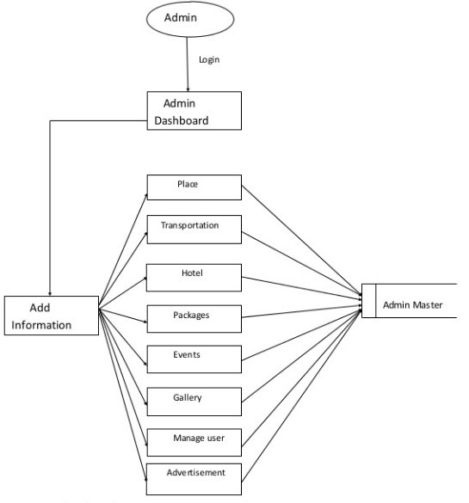](https://sites.google.com/site/ignoubcafinalyearprojects/project-report/tours-and-travel-management-system-project-report/1%20LEVEL%20DFD%20-%20TOURS%20AND%20TRAVELS%20MANAGEMENT%20SYSTEM.jpg?attredirects=0)**

**USER LEVEL 1 DED**

**[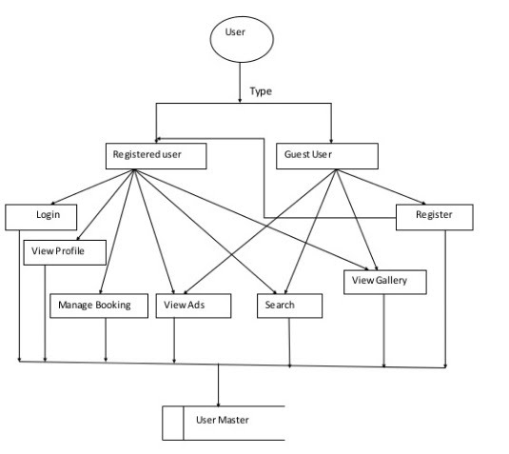](https://sites.google.com/site/ignoubcafinalyearprojects/project-report/tours-and-travel-management-system-project-report/1%20LEVEL%20DFD%20-%20USER%20-%20TOURS%20AND%20TRAVELS%20MANAGEMENT%20SYSTEM.jpg?attredirects=0)**

**LEVEL 2 DFD**

**[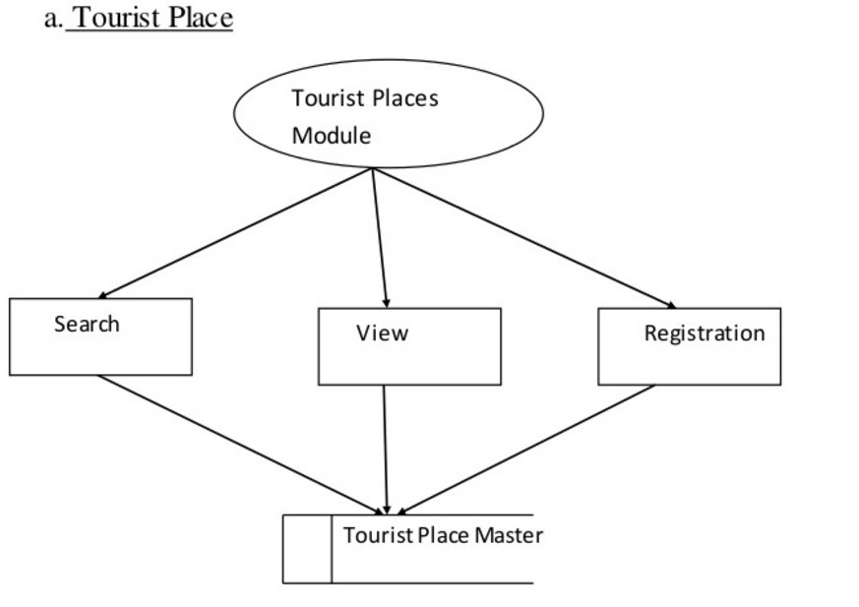](https://sites.google.com/site/ignoubcafinalyearprojects/project-report/tours-and-travel-management-system-project-report/LEVEL%202%20DFD%20TOURIST%20PLACE%20-%20TOURS%20AND%20TRAVELS%20MANAGEMENT%20SYSTEM.jpg?attredirects=0)**

**TRANSPORTATION**

**[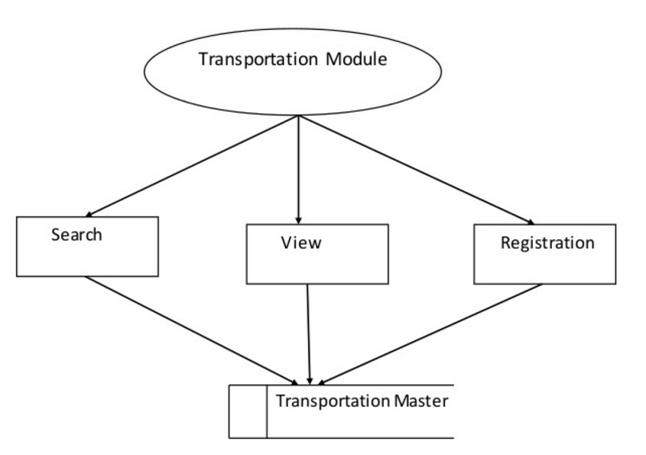](https://sites.google.com/site/ignoubcafinalyearprojects/project-report/tours-and-travel-management-system-project-report/LEVEL%202%20DFD%20TRANSPORTATION%20-%20TOURS%20AND%20TRAVELS%20MANAGEMENT%20SYSTEM.jpg?attredirects=0)**

**HOTEL**

**[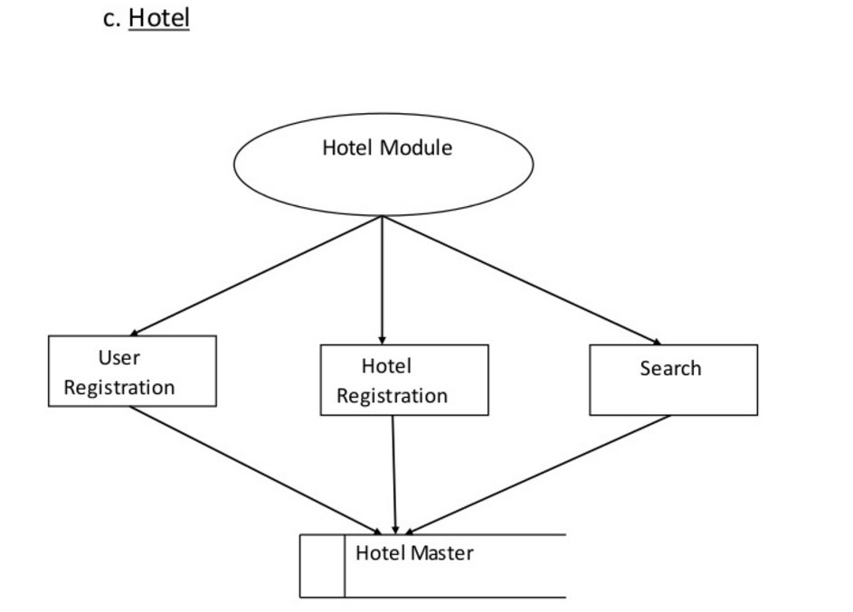](https://sites.google.com/site/ignoubcafinalyearprojects/project-report/tours-and-travel-management-system-project-report/LEVEL%202%20DFD%20HOTEL%20-%20TOURS%20AND%20TRAVELS%20MANAGEMENT%20SYSTEM.jpg?attredirects=0)**

**PACKAGES**

[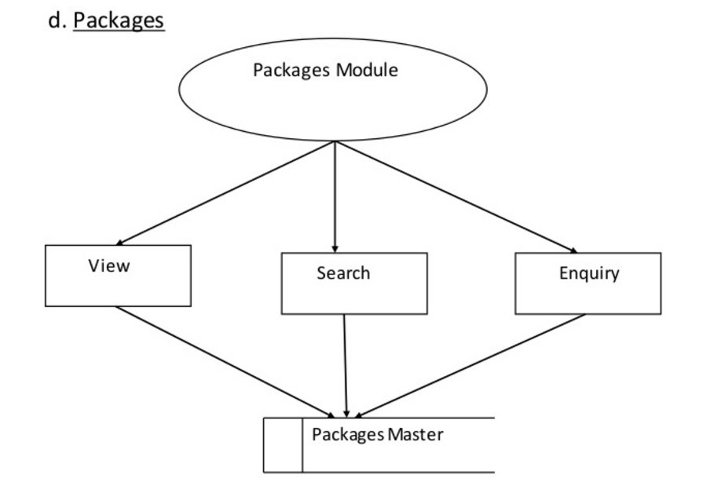](https://sites.google.com/site/ignoubcafinalyearprojects/project-report/tours-and-travel-management-system-project-report/LEVEL%202%20DFD%20PACKAGES%20-%20TOURS%20AND%20TRAVELS%20MANAGEMENT%20SYSTEM.jpg?attredirects=0)

* 1. **Conceptual level class diagram**

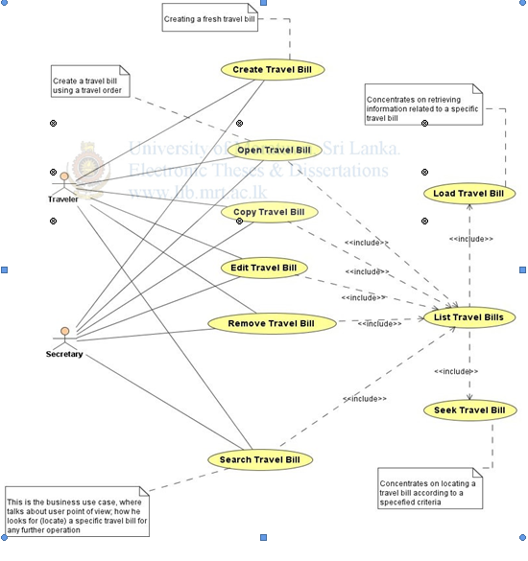

**4.3** **Conceptual level activity diagram**

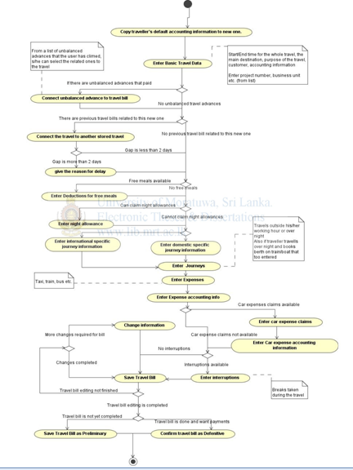

* 1. **Data flow Diagram( Level 0,1,2)**

**[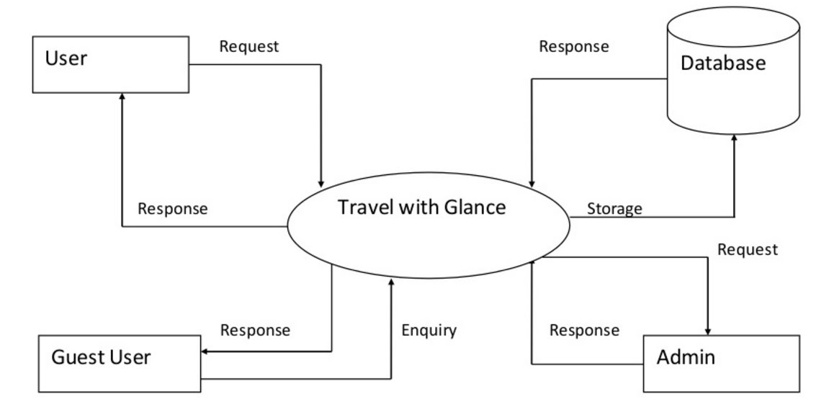](https://sites.google.com/site/ignoubcafinalyearprojects/project-report/tours-and-travel-management-system-project-report/CONTEXT%20LEVEL%20DFD%20-%20TOURS%20AND%20TRAVELS%20MANAGEMENT%20SYSTEM.jpg?attredirects=0)**

* 1. **Database Design (ER-Diagram)**

**ER DIAGRAM ADMIN**

**[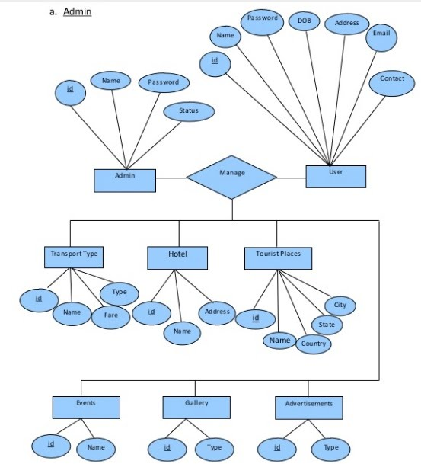](https://sites.google.com/site/ignoubcafinalyearprojects/project-report/tours-and-travel-management-system-project-report/ER%20MODULE%20ADMIN%20-%20TOURS%20AND%20TRAVELS%20MANAGEMENT%20SYSTEM.jpg?attredirects=0)**

**ER DIAGRAM USER**

**[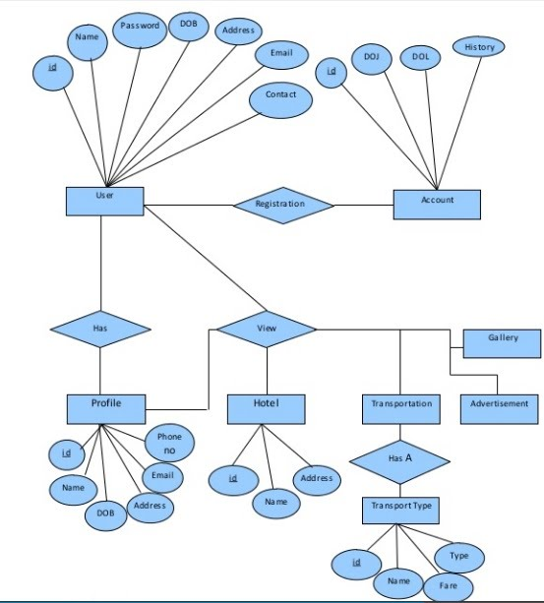](https://sites.google.com/site/ignoubcafinalyearprojects/project-report/tours-and-travel-management-system-project-report/ER%20MODULE%20USER%20-%20TOURS%20AND%20TRAVELS%20MANAGEMENT%20SYSTEM.jpg?attredirects=0)**

**HOTEL BOOKING**

**[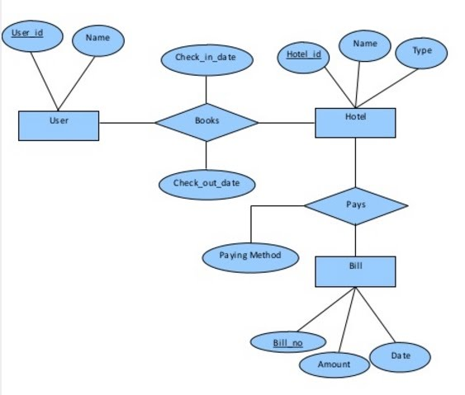](https://sites.google.com/site/ignoubcafinalyearprojects/project-report/tours-and-travel-management-system-project-report/ER%20MODULE%20HOTEL-%20TOURS%20AND%20TRAVELS%20MANAGEMENT%20SYSTEM.jpg?attredirects=0)**

**CHAPTER-5 SYSTEM MODELLING**

**5.1 Detailed Class Diagram**

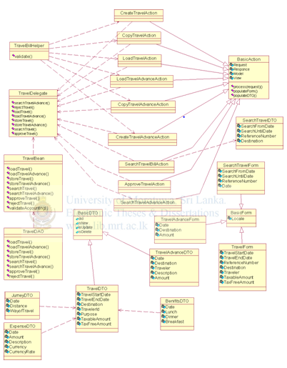

**5.2 Interaction Diagram**

**5.2.1 Sequence Diagram**

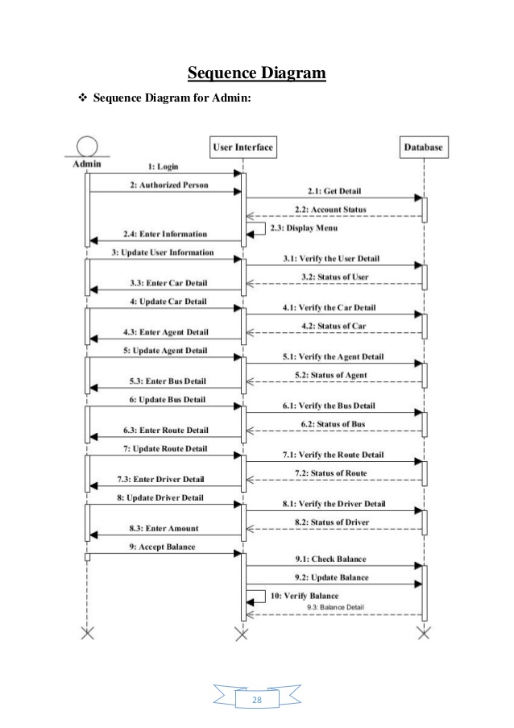

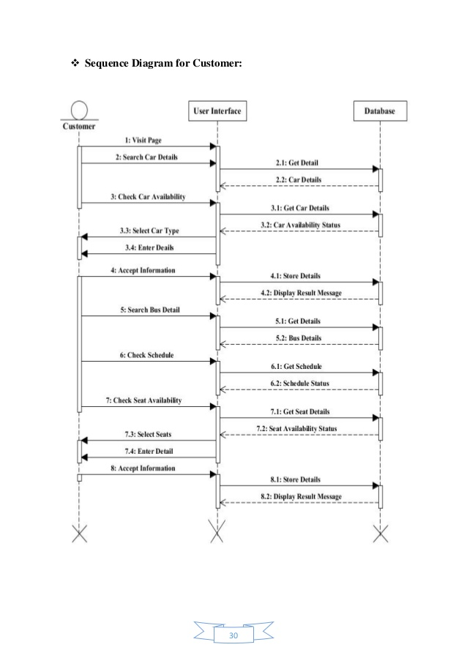

**5.2.2 Collabration Diagram**

[](https://sites.google.com/site/ignoubcafinalyearprojects/project-report/tours-and-travel-management-system-project-report/CONTEXT%20LEVEL%20DFD%20-%20TOURS%20AND%20TRAVELS%20MANAGEMENT%20SYSTEM.jpg?attredirects=0)

**5.3 State Diagram**

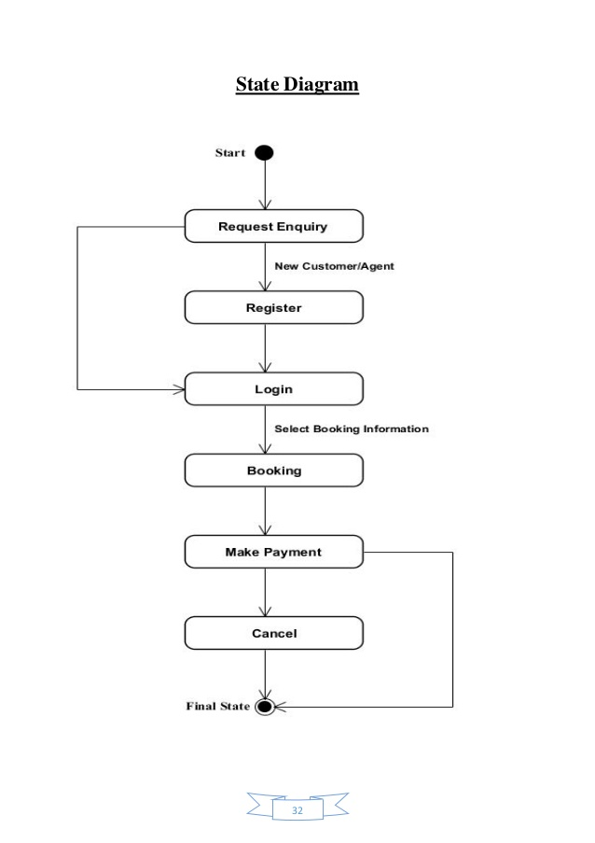

**5.4 Activity Diagram**

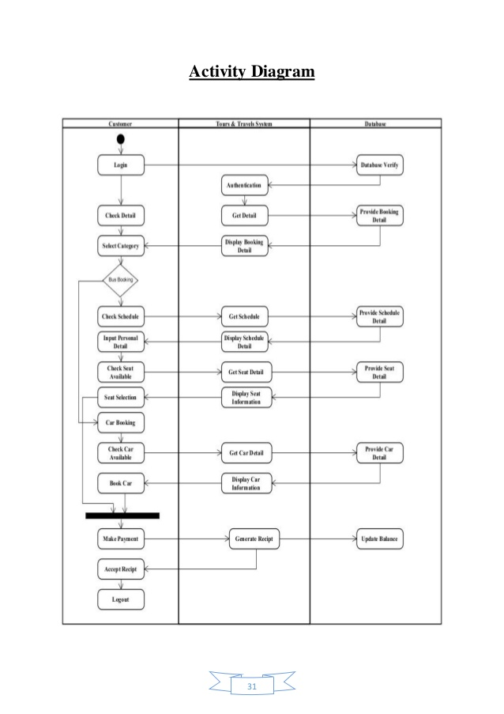

**5.5 Component Diagram & Deployment Diagram**

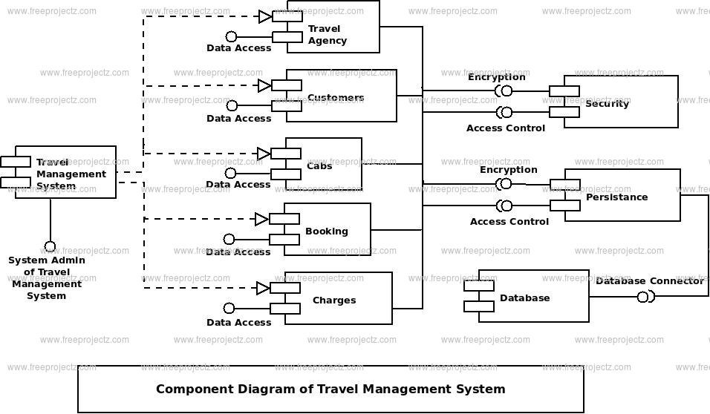

**5.6 Testing**

Testing is the major quality control that can be used during software development. Its basic function is to detect the errors in the software. During requirement analysis and design, the output is a document that is usually textual and non-executable. After the coding phase, computer program is available that can be executed for testing purposes. This implies that testing not only has to uncover errors introduced during coding, but also errors introduced during previous phases. Thus the goal of the testing is to uncover requirement, design and coding errors in the program.

An elaborate testing of data is prepared and the system is tested using that test date. Errors noted and corrections made during the testing. The corrections are also noted for future use. The users are trained to operate the developed system. Both hardware and software securities are made to run the developed system successfully in future. System testing is the stage of implementation, which is aimed at ensuring that the system works accurately before live operation commences. Testing is vital to the success of any system. System testing makes a logical assumption that if all the parts of the system are correct, the goal will be successfully achieved.

## Testing Objectives

* Testing is a process of executing a program with the intent of finding an error.
* A good test case is one that has a high probability of finding an undiscovered error.
* A successful test is one that uncovers an as-yet undiscovered error.

**Testing Principles**

* All tests should be traceable to customer requirements.
* Tests should be planned long before testing begins.
* Testing should begin “in the small” and progress toward testing “in the large”.
* Exhaustive testing is not completely possible.
* To be most effective, testing should be conducted by an independent third party.

**Testing Methods & Strategies used  along with test data and the error listed for each test case for each function provided by the system**

System testing is the process of executing software in a controlled manner, in order to answer the questions "Does the software behave as specified?"

System testing is often used in association with the terms verification and validation Verification is the checking of tems, including software, for conformance and consistency with an associated specification Software testing is just one kind of verification,which also uses techniques such as reviews, analysis, inspections and walkthroughs.

**Validation :** Are we doing the right job ?

**Verification:** Are we doing the job right?

**CHAPTER-6 CONCLUSION & FUTURE WORK**

**6.1 Limitation of Project**

* Unable to access without the internet.
* weather forecasting can be done only 4-5 days before the date of travel so if a user is booking earlier than that then he might not be able to know the weather conditions of the destination.So,customers are recommended to book within that time period if possible.

**6.2 Future Enhancement**

* Proactiveness by predicting customer problems.
* Deliver augmented reality.
* Create an illusion of physical presence with 3D-technology and holograms.

**CHAPTER-7 BIBLIOGRAPHY & REFRENCES**

1. **Other Documentations & Resources**
2. http://www.fit.vutbr.cz/study/courses/ITS/public/ieee829.html
3. https://techwhirl.com/user-guide-template/
4. https://www.onetonline.org/search/t2/examples/43231507?s=management%20software
5. http://www.projectinsight.net/project-management-basics/project-managementschedule
6. https://techwhirl.com/business-requirements-document-brd-template/
7. https://web.cs.dal.ca/hawkey/3130/srstemplate−ieee.dochttps : //bia.ca/risk management the what why and how/

1. **Snapshot (with description)**

**1. Homepage:**

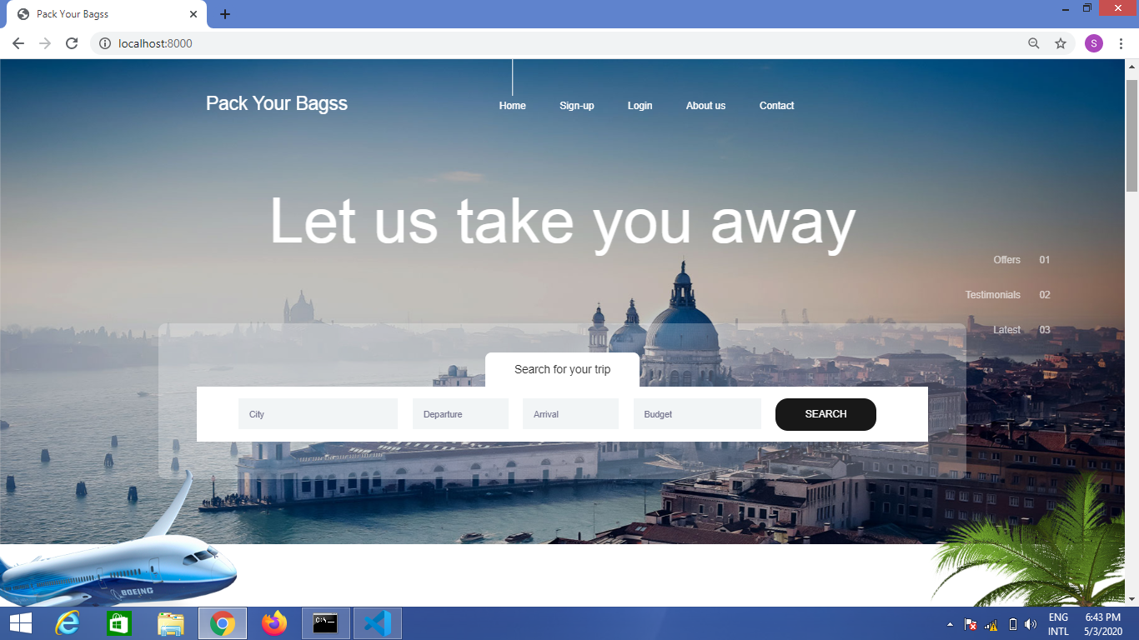This is the face of our website from where user can visit any other page such as sign-up ,login,contact us,about us.User can also search for a trip but for this purpose they are needs register themselves first.

**2. Sign-up**

User needs to sign-up or register themselves so that they can fully visit our website. They can also sign-up through their google or facebook accounts. Register validations are also provided so that they may not be able to fill up wrong information.

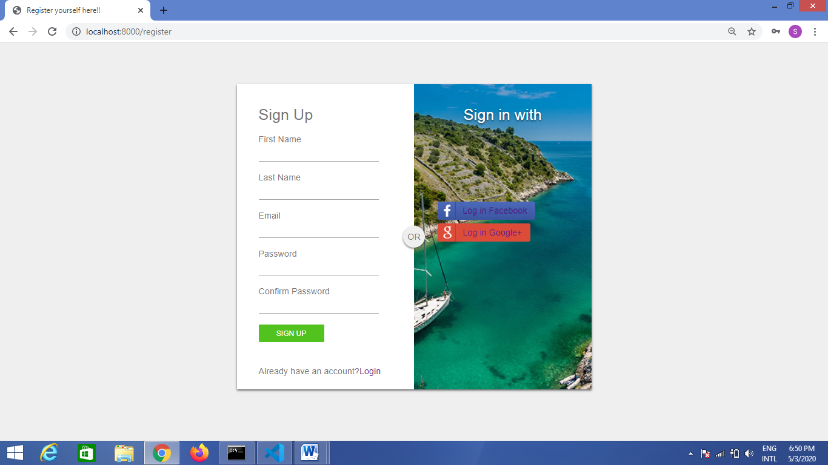

**3. Log-in**

Users who are already registered or signed-up can dierecty login to the website and can see their respective profiles. Login validations are also provided so that they may not be able to logged-in if they are not registered or if they are filling wrong information.

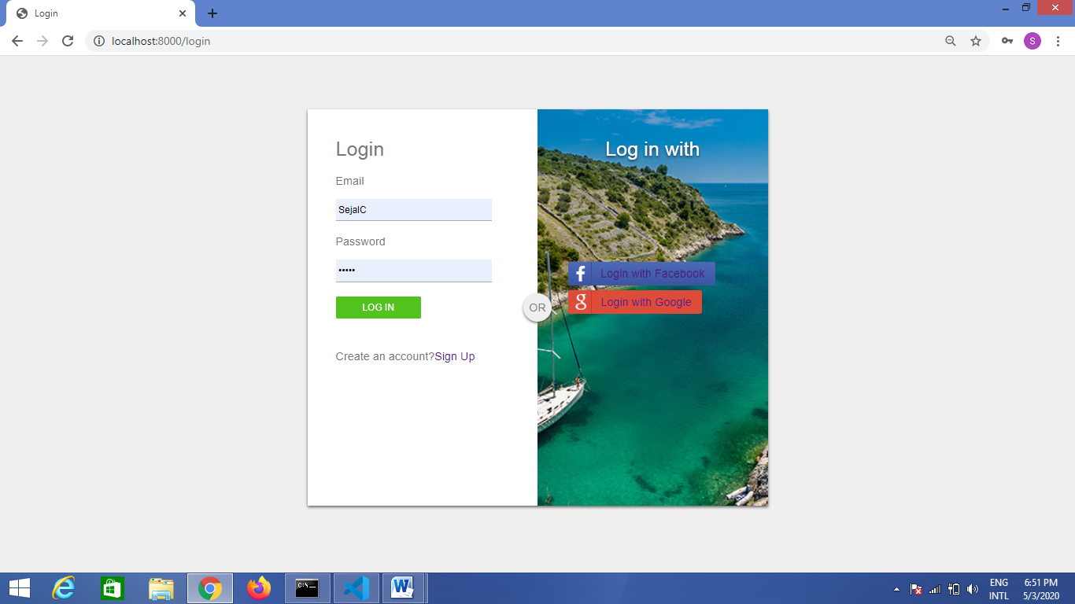

**4. Explore Destinations By Season**

This is the part of the homepage. Users who are already registered can visit different destinations and can do bookings. Destinations are provided according to different seasons like Manali is best to visit in summer season , etc.

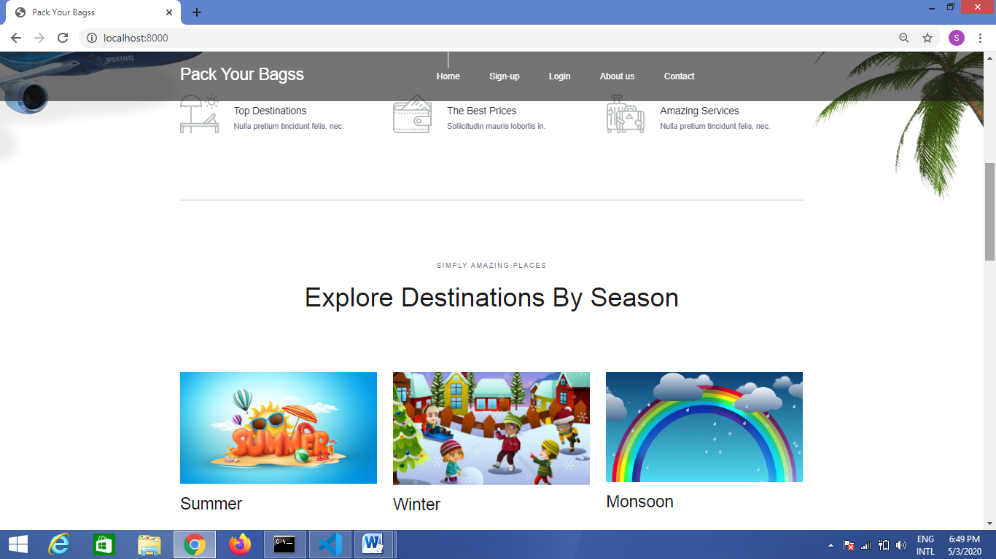

**5.Popular Destinations**

If user selects summer then he will be redirected to this page where he could see top destinations which are best to visit in summer season. Destinations are also provided with ideal duration to explore that place and estimated price per person. We are giving different options like hotel booking, meals,etc as explained below.

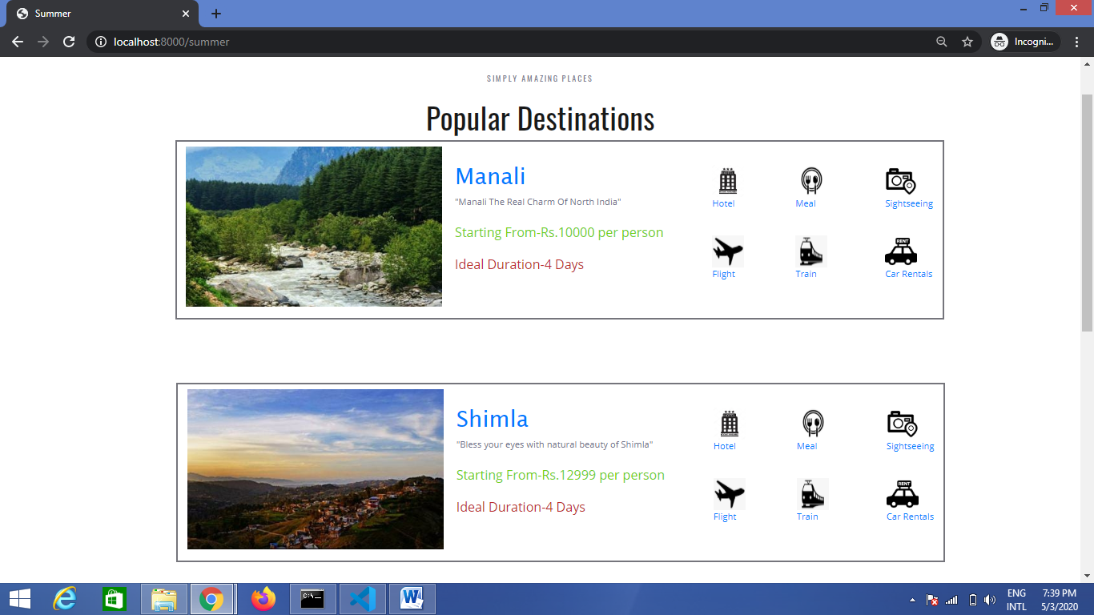

**6. Hotel Booking:**

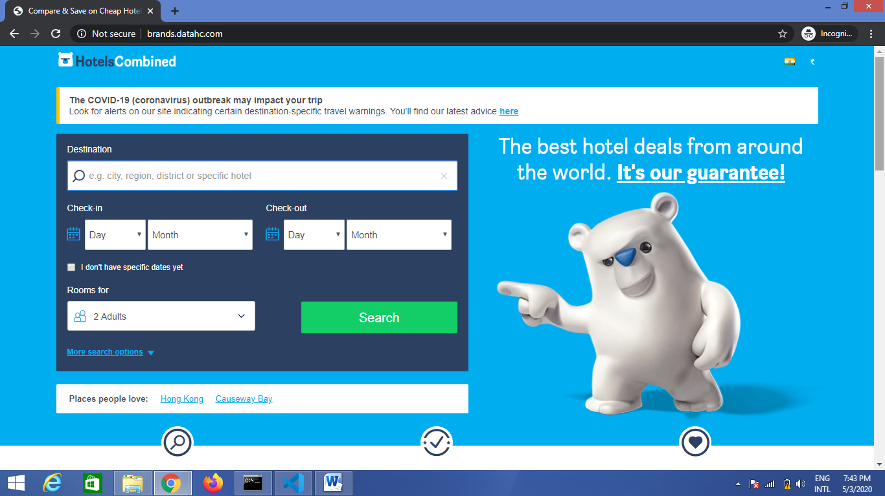

1. **Flight Booking**

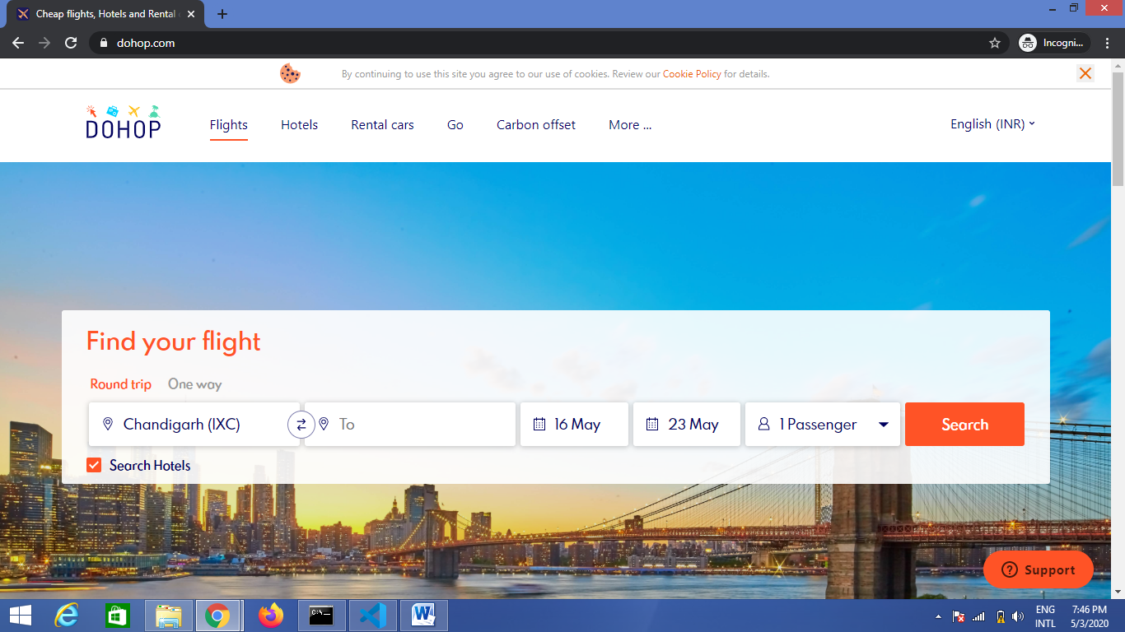

**8. Train Booking**

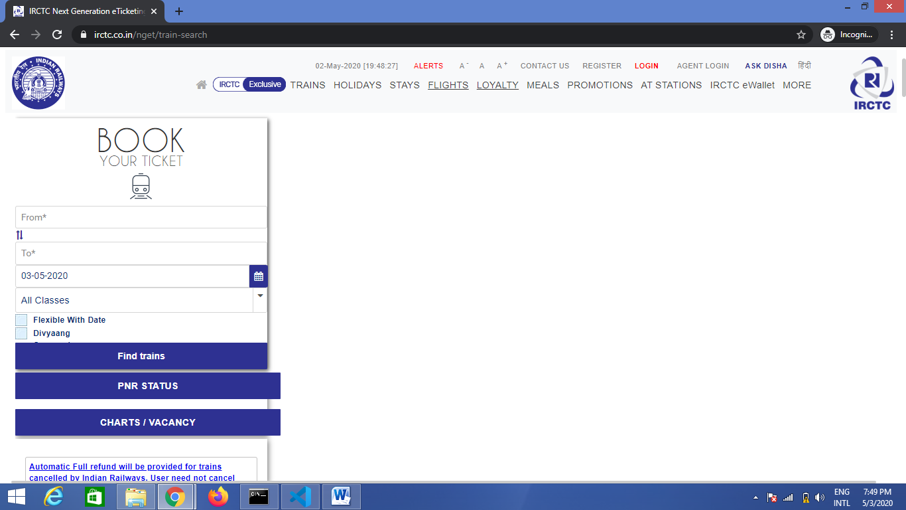

**9. Rental Cars Booking**

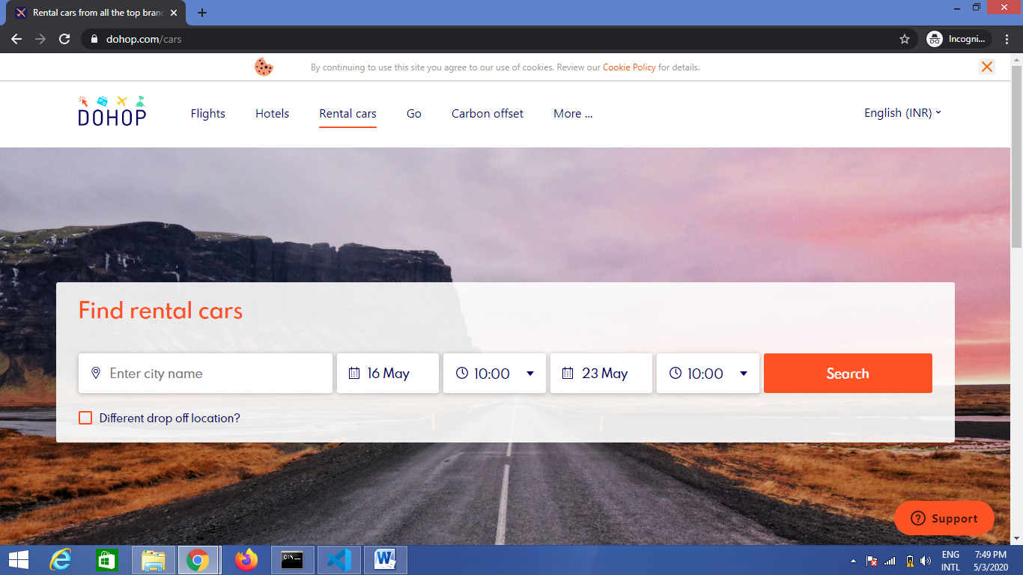

**10. Meals**

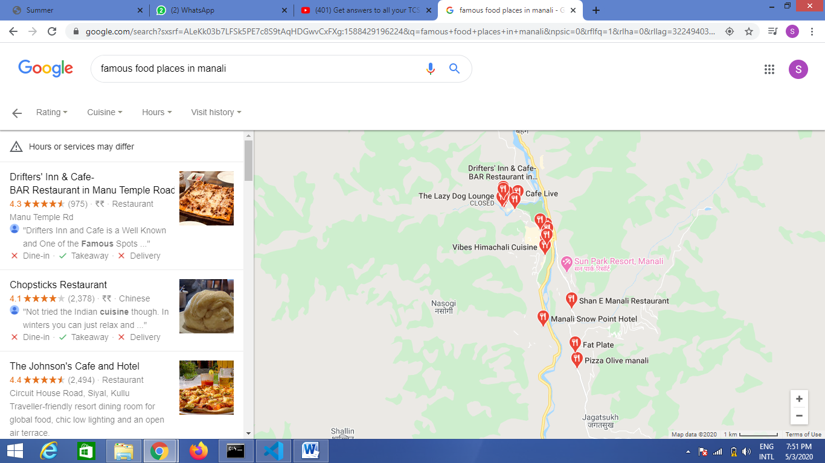

**11. Sightseeing**

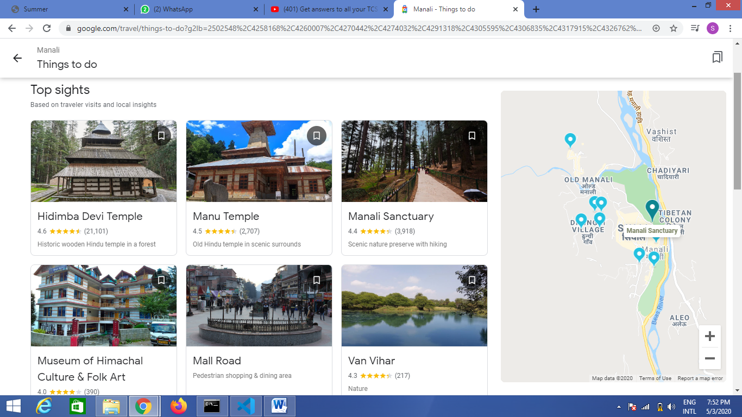

**12. Dashboard**

User can create their trip here by filling up valid dates. They can edit or remove their trip in dashboard.

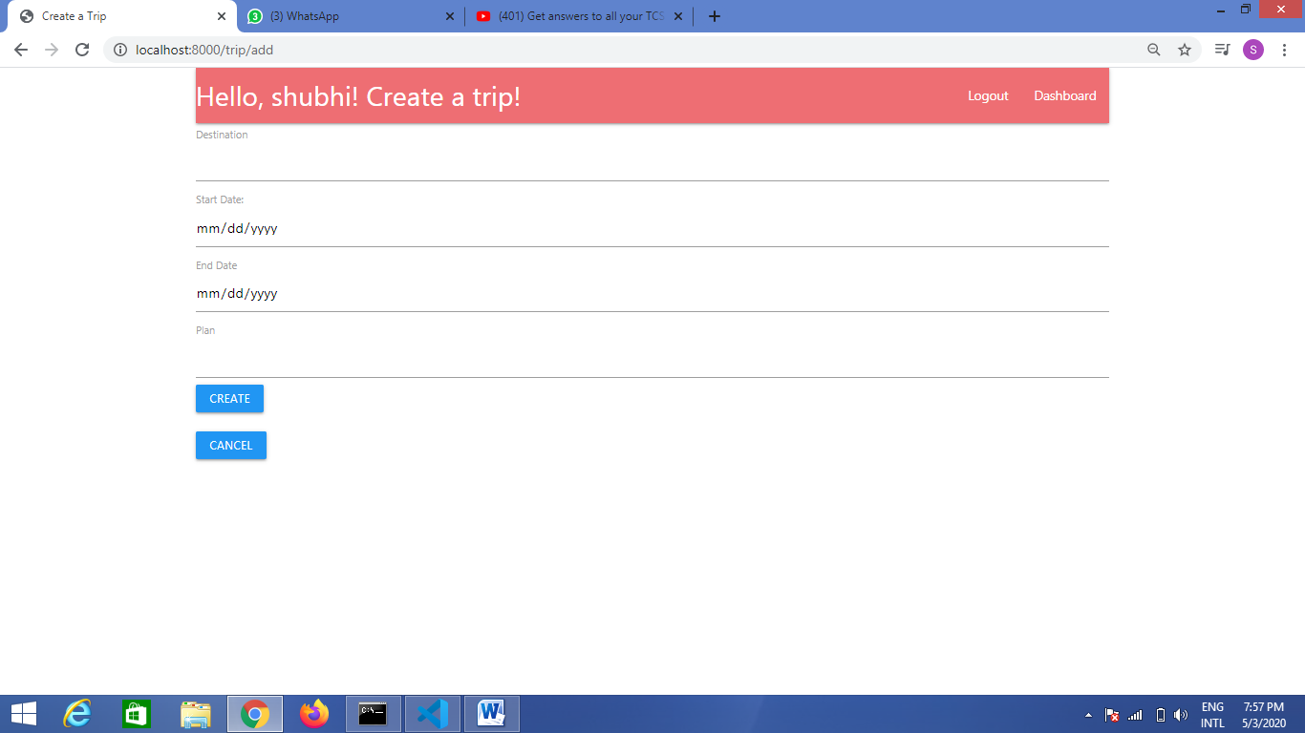

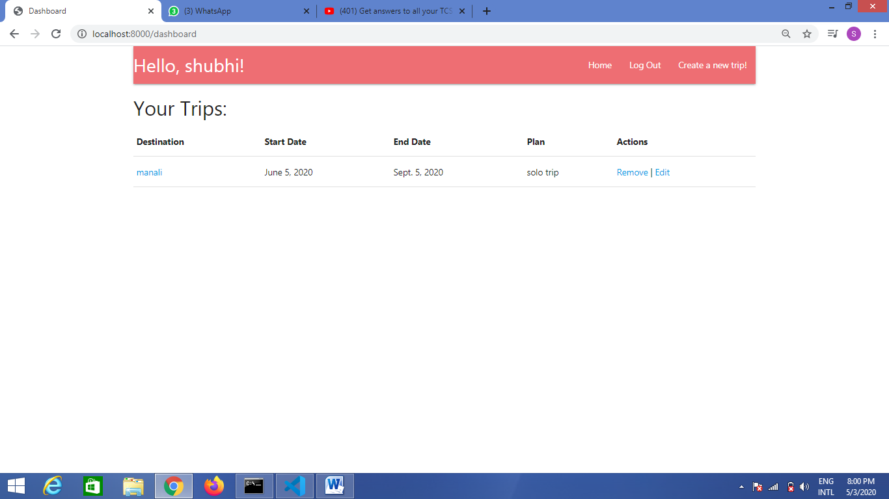

**13. Django Administration**

This can be only seen and edited by Admin.

